Ф Р А З Ы для написания Л И Ч Н О Г О П И С Ь М А (9 кл)

- ДАТА:

Tver
Russia
26/03/2013

- ОБРАЩЕНИЕ:

Dear John,

- БЛАГОДАРНОСТЬ ЗА ПИСЬМО:

Thanks (a lot) for your (last) letter. It was great to hear from you again!
Your last letter was a real surprise.
I was glad to get your letter.
I was so happy to get your letter.
It was great to hear from you!
How nice of you to write me the letter.
I was happy to hear from you (again)!
Thank you for your letter. I’m awfully sorry for not writing for so long because I’ve been busy at school studying for my exams. How are you keeping?
I'm sorry I haven't written for such a long time, but I've been really busy with my new job as a DJ. Actually, that's what I'm writing to tell you about.

- ИЗВИНЕНИЯ ЗА ЗАДЕРЖКУ ОТВЕТА:

Sorry I haven’t written for so long but I was busy at school preparing for my exams.
Sorry I haven’t been in touch for so long.
I'm sorry I haven't answered earlier but I was really busy with my school.
Sorry, I haven’t written for so long.

I must apologize for not writing for so long.

I really should have written sooner.

I’m sorry I haven’t answered earlier but I was really busy with my school.

How are you? I hope all is going well.

How are things with you?
- Слова-связки (для ответов на вопросы):

First of all, I’d like to tell you about my visit to Paris last month. We were greatly impressed by its beauty. All in all, we enjoyed our holidays.

Well, in your letter you asked me about…

You asked me to tell you about…

You are asking me about……. I’ll do my best to answer your questions.

Actually,
Well,
By the way,
Anyway,
However,
So,
As for me,
Though,

(Un)fortunately,
Frankly speaking,
Besides,
Moreover,
All in all,
First of all,

- Задать все необходимые вопросы:

And what about you?

First of all, let me ask you some questions.

By the way, let me ask you some questions (about)…
By the way, tell me more about…
By the way, I want to know more about …( you and your life).

- Объяснить, почему вы заканчиваете письмо:

Well, I’d better go now as I have to do my homework.

Anyway, I have to go now because my Mum asked me to help her with the washing up ( and cleaning the flat).

I’ve got to go now! It’s time for my favourite TV show.

I’d better go now as I have to take my dog for a walk.

I’d better go now. Mum wants me to help her with the housework.

Well, I’d better go now as I have to tidy up my room.

I’ve got to go now! It’s time for my music lesson.

Unfortunately, I’d better go now as I’ve got loads of homework to do.

Well, that’s all for now.
That’s all my news for now.
Well, I must finish now — my lessons begin in half an hour.

- Oбязательно упомянуть о дальнейших контактах:

Write (back) soon!

Take care and keep in touch!

Drop me a letter when you can.

Hope to hear from you soon.

I can’t wait to hear from you!

Looking forward to seeing you.

Write soon!

Anyway, let me know if you have any other questions.

We all miss you. Everybody sends their love. Can’t wait to see you in the summer. Write back soon.

Drop me a line when you can.

I can’t wait to meet you in July.

Give my regards to your Mum.

I would really like you to visit me this summer.

Anyway, that's all my news for the moment, but I promise I'll write again soon. I hope you and your family are well. Keep in touch!

- Завершающая фраза:

Best wishes,

Best regards,

All the best,

Lots of love,

All my love,

Yours,

10. Подпись ( без точки!!!!!):
Anna

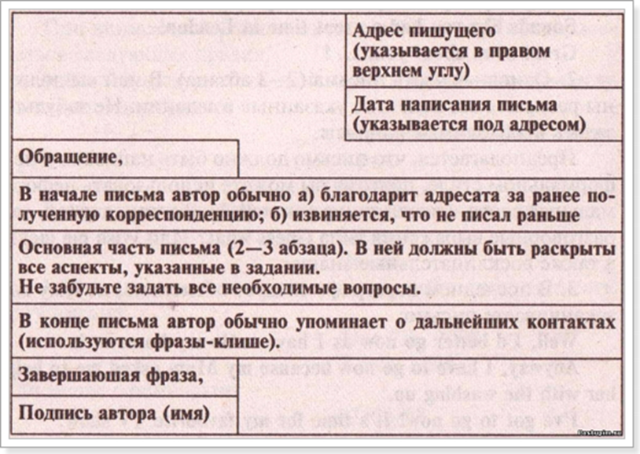

Шаблон письма другу на английском языке:
Tver
Russia
15/02/2017
My dear ………,
Thanks for your letter. It was great to hear from you again! I’m sorry I haven’t written for so long but I’ve been really busy with…….(preparing for my exams).
You are asking me about……. I’ll do my best to answer your questions. (отвечаете на вопросы). Actually, ……. Frankly speaking, ……. Finally,………
Неге is some news about ……… ( рассказываете новости)
And what about you? Let me ask you some questions. ……….. (задаете свои вопросы)
I must finish my letter because it is very late and I must go to bed. Hope to hear from you soon.
Love,
Mary

ТЕКСТЫ ЛИЧНОГО ПИСЬМА
Moscow
Russia
1/12/2015
Dear Andrea,
Thank you for your letter. I’m awfully sorry for not writing for so long because I’ve been busy at school studying for my exams. How are you keeping?
In your letter you took a deep interest in my hobbies. Well, I do collect small things and most of them are small figures of penguins. Frankly speaking, I like buying clothes on my pocket money. My mother doesn’t like it and we often argue. My friends spend their money on going to the cinema or on computer games. Isn’t it silly?
As I’ve heard you have just entered courses. What courses do you attend? Do you go alone or with your friends? Do you enjoy spending your time there?
Well, got to go now.
Keep in touch. Write soon.
Best wishes,
Kate
Moscow
Russia
1/12/2015
Dear Alice,
Thanks for your letter. It was great to hear from you. Sorry I haven’t been in touch for so long.
In your letter you asked me about my summer holidays. Well, I had a very good time! In June I stayed at home because I had exams at school. Luckily the weather was nice and warm at the weekend and we went to our country house. We went sunbathing and swimming in the lake near there. In July I went to a summer camp. It was fantastic. I made a lot of new friends. Every day we went swimming in the river, and we played different games. There was a disco every night. Once we went hiking in the forest for two days. We cooked our meals on the fire and at night we sat around the fire, sang songs and told stories.
Are you happy with your new house? Is it bigger than your old house? Have you got a room of your own? Please tell me more about it.
I’d better go now as I have to take my dog for a walk.
Hope to hear from you soon. Looking forward to seeing you.

Best wishes,
Tanya

